**Practical No. 6**

**Aim:** Implement the NFS with the vCenter Server.

This practical depends on the **Practical No. 4 A**

First go to the Disk C then Create a Folder (i.e. NFS_Share)

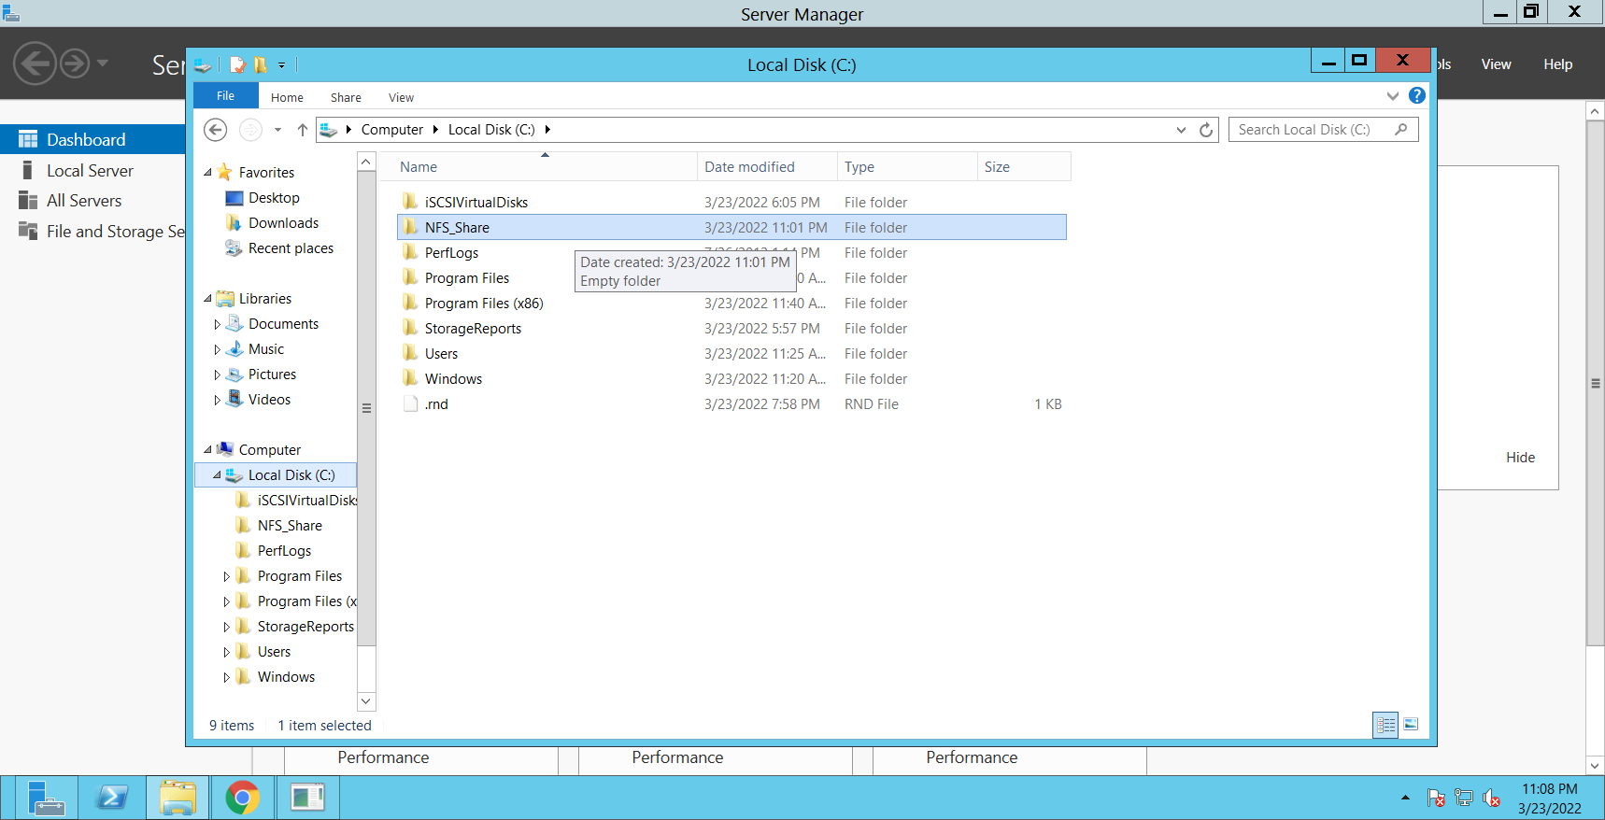

Go to the **folder properties** and after that click on the **NFS sharing** tab

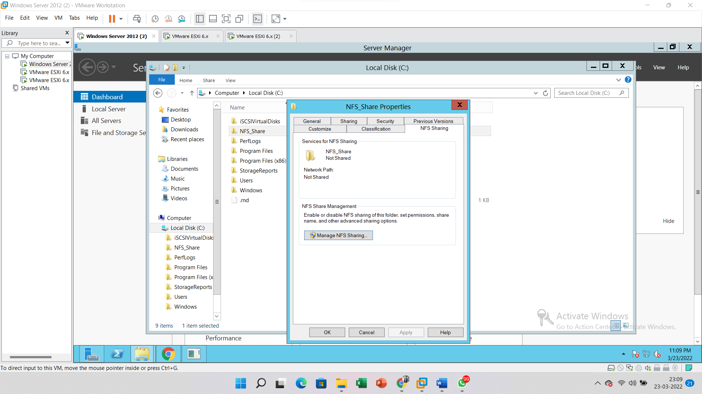

Click on the **Permissions**

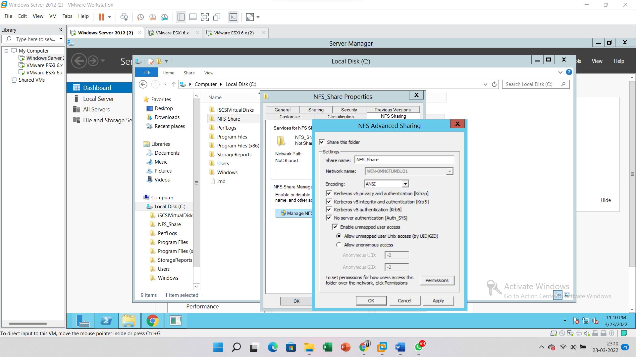

And select the **Read-Write** option into the Type of access and **ANSI** option into the Encoding and Click on the **OK** button

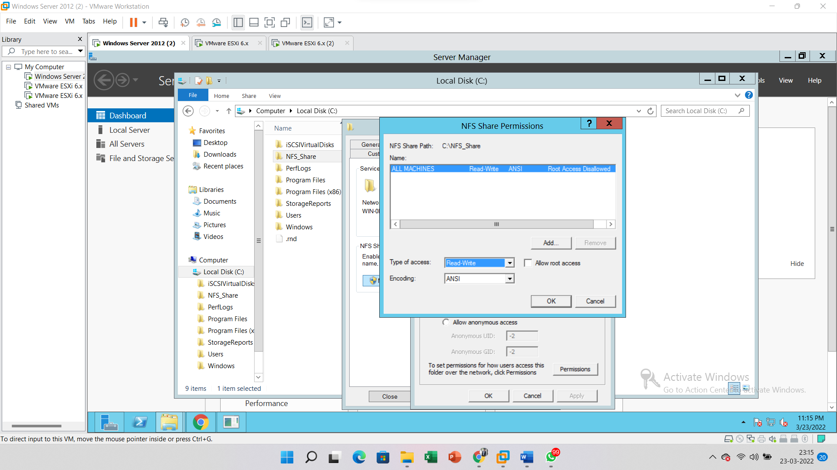

Click on the **Apply** button

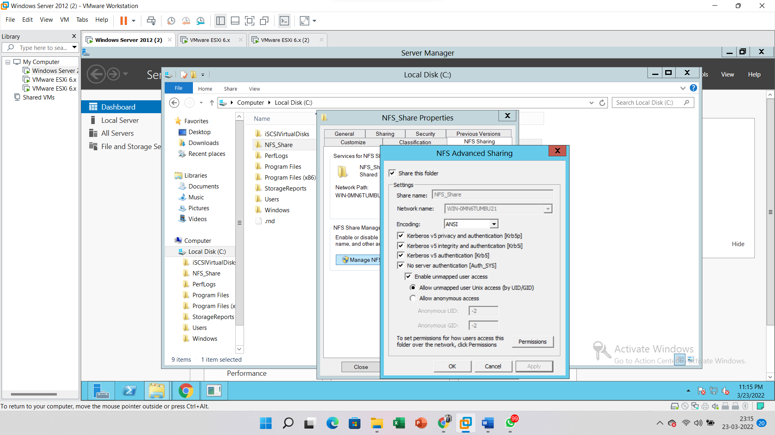

Right click on the **Host** and Go to the **Storage**. Click on the **New Datastore** option

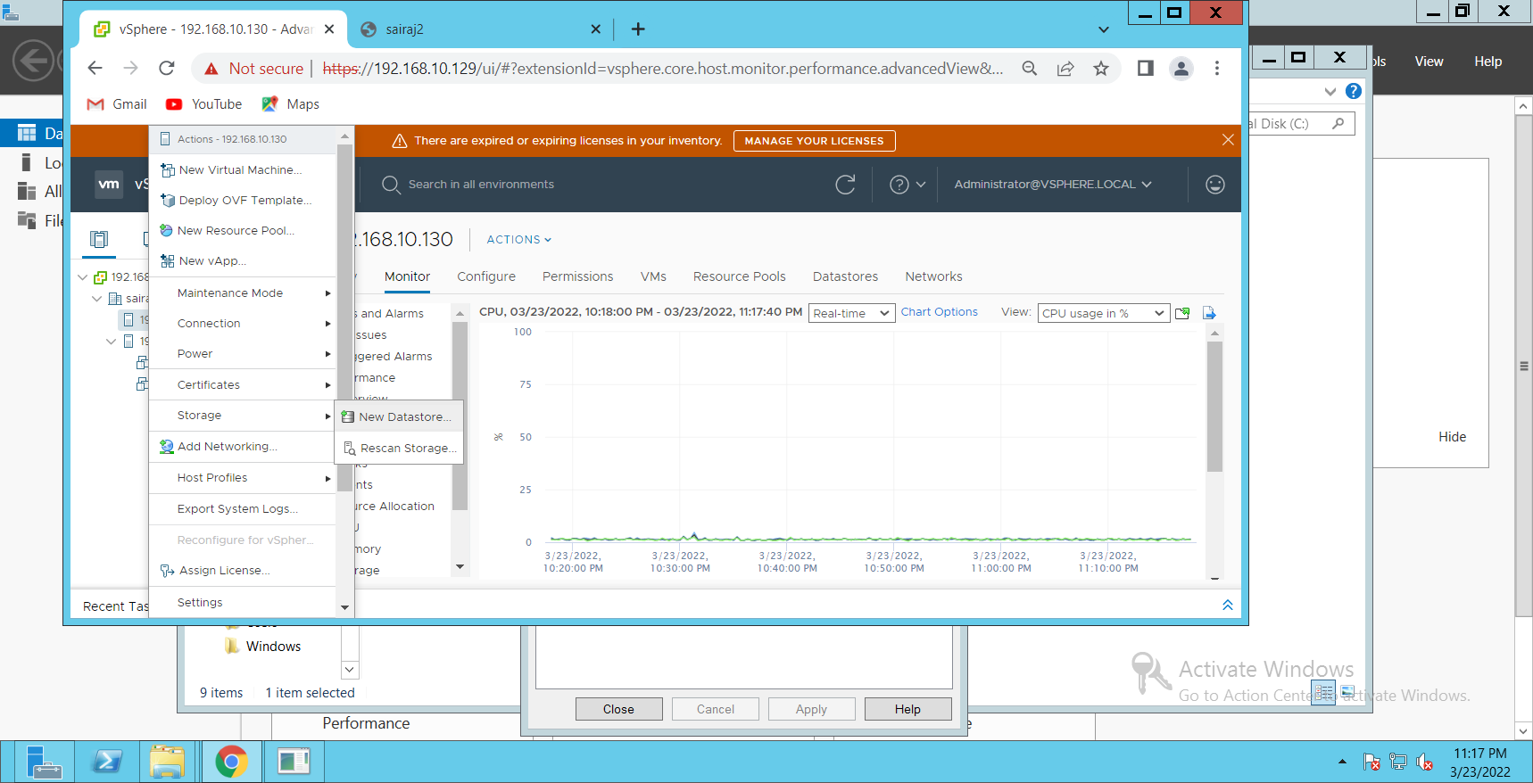

Choose the **NFS** option and Click on the **Next** button

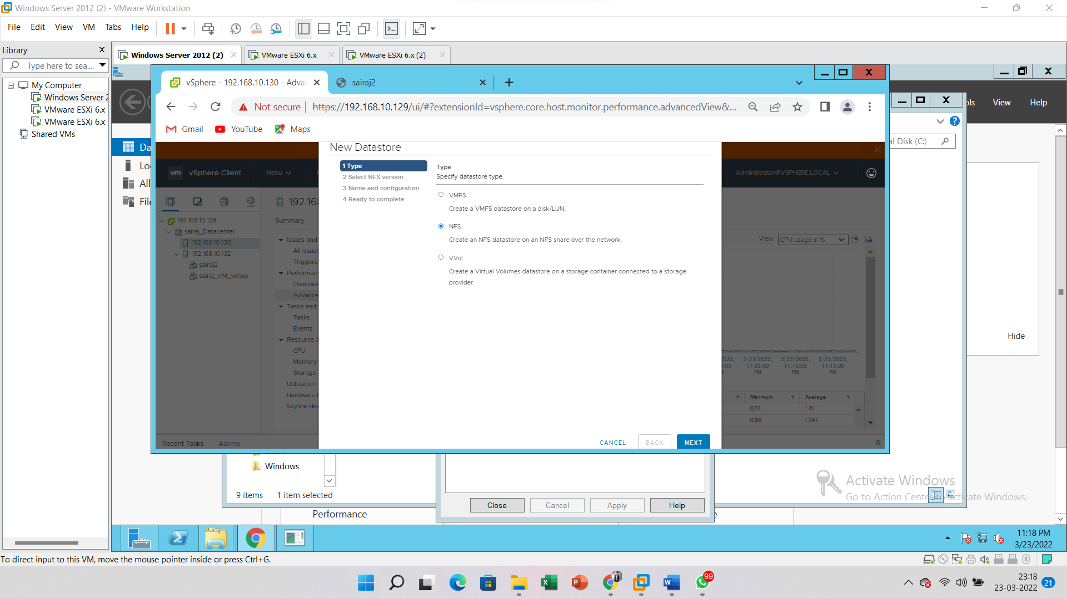

Select the **NFS version** and click on the **Next** button

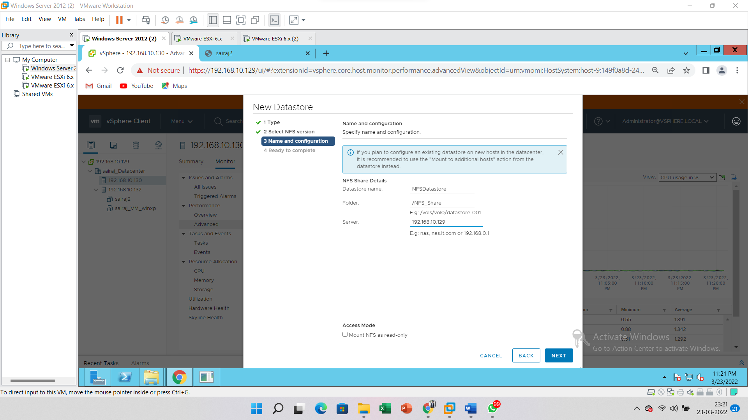

Enter the **Datastore** Name, **Server** IP address and **Folder** (Created folder into Disk C) and Click on the **Next** button

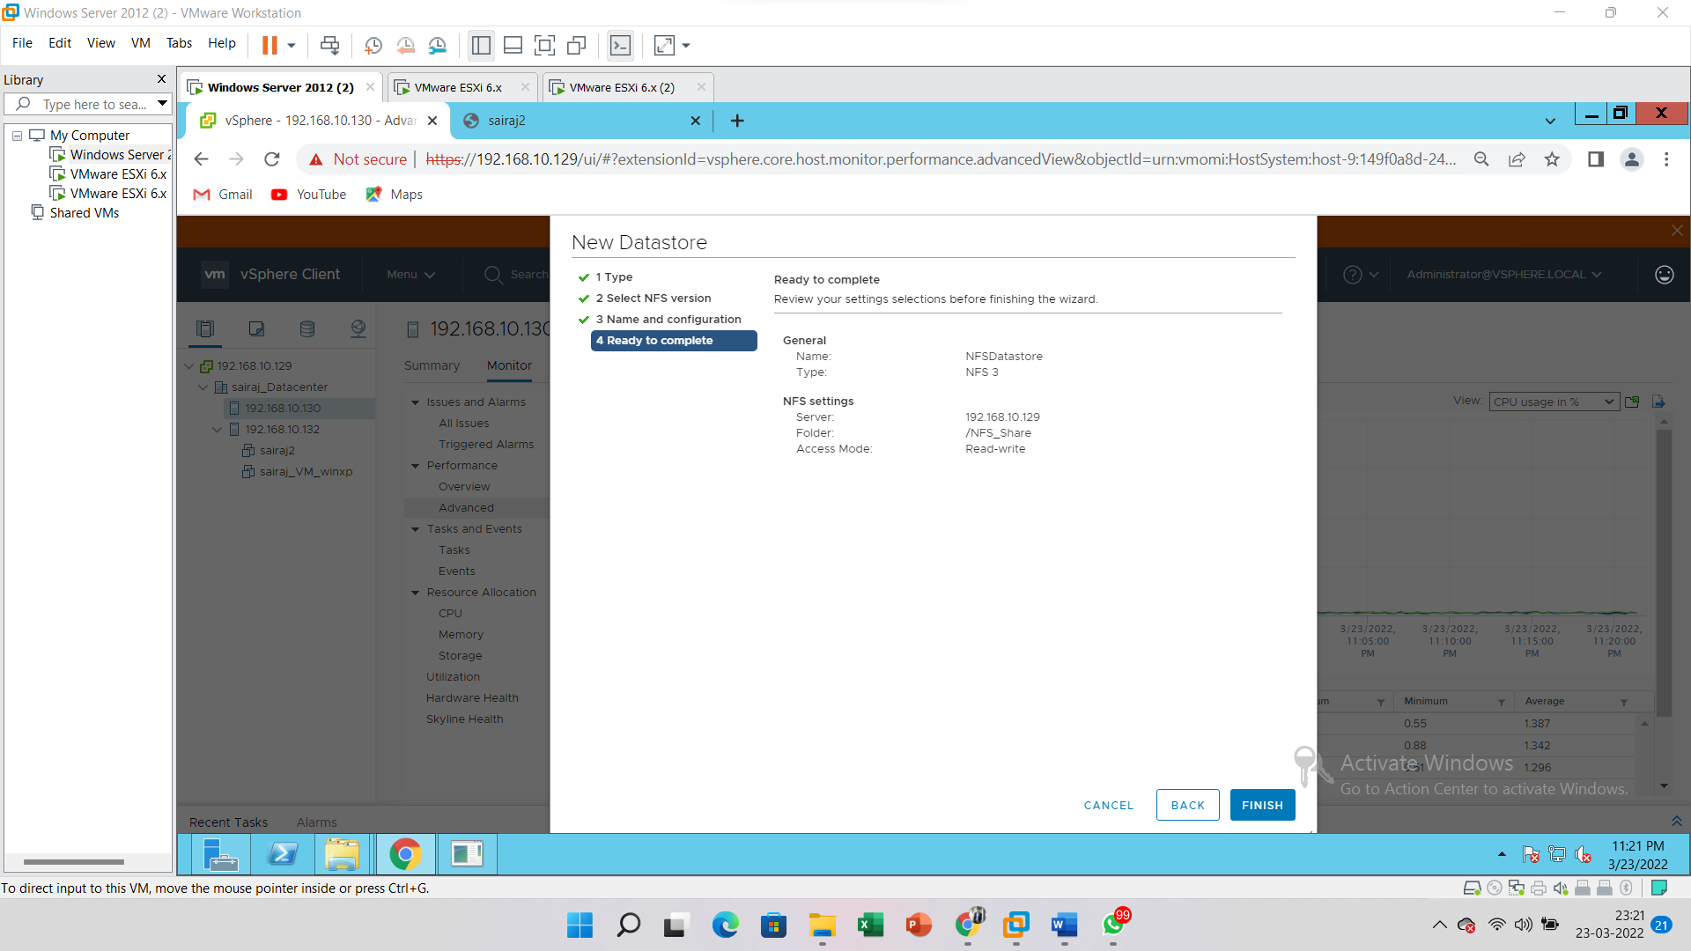

Click on the **Finish** button.

